  - DH 3264 - Derivatives OTC Customer Phase 1 (NDF)​
  - Business Requirements Document

US PMO Template

Document Version: | 1.0

Originated by: Domingo Megía

Approvers
This document has been approved by the Business Sponsor, or delegate, as the official Business Requirements Document for the project. Following approval of this document, changes will be governed by the project’s change control process, including impact analysis, appropriate reviews and reapprovals.

Business Line | Colleague Name | Colleague Title | Approval email  attachment | Date (MM/DD/YYYY)
Treasury | Ted Fernandez | Treasury – Business Owner | 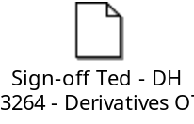 | 10/23/2025

Contributors & Reviewers

Colleague Name | Colleague Title | Business Line
Domingo Megia | Project Manager Lead | Treasury & Markets
Ricardo Valdivia | Product Owner – Treasury | Treasury & Markets

Peer Reviewers
The following Peer Review team members acknowledge the completion of the analysis and discussion of the BRD with the business analyst, and attendance in the Peer Review meeting.
COE Peer Reviewer | Peer Reviewer 1 | Peer Reviewer 2 | Peer Review Meeting Date
NA | NA | NA | NA

Not applicable since this is not an Executive project

Revision History

Version Number | Revision Date  MM/DD/YYYY | Summary of Changes | Revised By
1.0 | 09/10/2025 | Final version | Domingo Megia

References

Reference # | Document Name | Document
NA | NA | NA

Terms and Definitions

Term | Definition
NDF | Non-deliverable FX Forward contract

Table of Contents
1 Project Summary 8
1.1 Project Background and Overview 8
1.2 Assumptions/Dependencies/Constraints 8
1.2.1 Requirements Assumptions & Dependencies 8
1.2.2 Project Constraints 9
1.3 Out of Scope 10
1.4 Business/Customer/Channel Impact 11
2 Current and Future States 11
2.1. Current State 11
2.2 Future State 11
3 Requirements 12
3.1 Business Requirements 12
4 Non-Functional Requirements 13
4.1 Security 13
4.2 Data Governance 13
4.3 Auditability 13
4.4 End User Ease of Usability 13
4.5 Performance Efficiency 13
4.6 Scalability 13
4.7 Reliability 13
4.8 Business User Maintainability 14
4.9 Backup and Recovery 14
4.10 Availability 15

Project Summary

Project Background and Overview

The objective is to add Non-Deliverable FX Forward contracts (NDFs) to our current client offerings. An NDF is a cash-settled foreign-exchange forward contract in which the two currencies are not exchanged at maturity (hence "non-deliverable"). On the settlement date, the counterparties settle the difference between the contracted NDF price and the prevailing spot price. The profit or loss is calculated on the notional amount of the agreement by taking the difference between the agreed-upon rate and the spot rate at the time of settlement.

Assumptions/Dependencies/Constraints

Requirements Assumptions & Dependencies
                - Overall Scope:
- Entities: Banco Santander International Miami (BSI). BSI Clients.
- Product: Non-Delivery Forward (NDF).
- Currencies:
- Colombia (COP) – USD
- Chile (CLP) – USD
- Argentina (ARS) – USD
- Brazil (BRL) – USD
- Perú (PEN) – USD

                - Systems:
- T24 NDFs Module R11
- MEDEA
- 360

                - Stream Scope :
- Trading (T24): includes booking and pre-trade checks.
- T24 connection to MX and then flowing to rest of global systems.
- Confirmations
- Middle office activities
- Medea feeding, Medea processing and Client Statement update (360).
- Report adjustments.
- Regulatory Reporting.

                - The requirements in this BRD have the following assumptions and dependencies:
- Assumption or Dependency? | - Related Requirement Number | - Note the Assumption or Dependency
- A1 | - 1,2,3,4,5,6,7,9,10 | - ND Module of T24 can be setup/developed to sastisfy all requirements defined within this document
- A2 | - 7,8 | - There is an existing connection between T24 and Medea
- A3 | - 6 | - There is an existing connection between T24 and Murex
- D1 | - 6 | - Developments in Global system depend on Global IT teams from SGTO.

Project Constraints

                - The project has the following constraints:
- Number [C#] | - Constraint
- C1 | - Dependency on existing system capabilities
- C2 | - Project is costrained by Dodd Frank
- C3 | - Resource availability

Out of Scope
The following components are out of scope of this BRD:

- Number | - Out of Scope Item
- OOS1 | - Improvements in FX product functionalities not requested as requirement
- OOS2 | - Tax Withholding requirements that will part of release 2
- OOS3 | - Annual fiscar report requirements that will part of release 2

1.4 Business/Customer/Channel Impact

Business/Customer/Channel | Impact Description
Risk and REC calculations // FX process. | NDF will include a new methodology for calculating risk exposure that will be implemented also in FX, impacting curren process of FX.
System integration | Connects multiple systems (Medea, T24 and Murex to ensure data consistency and visibility across all involved areas.

Current and Future States

Current State

NA since this product is not implanted today. There is no current state.

Future State
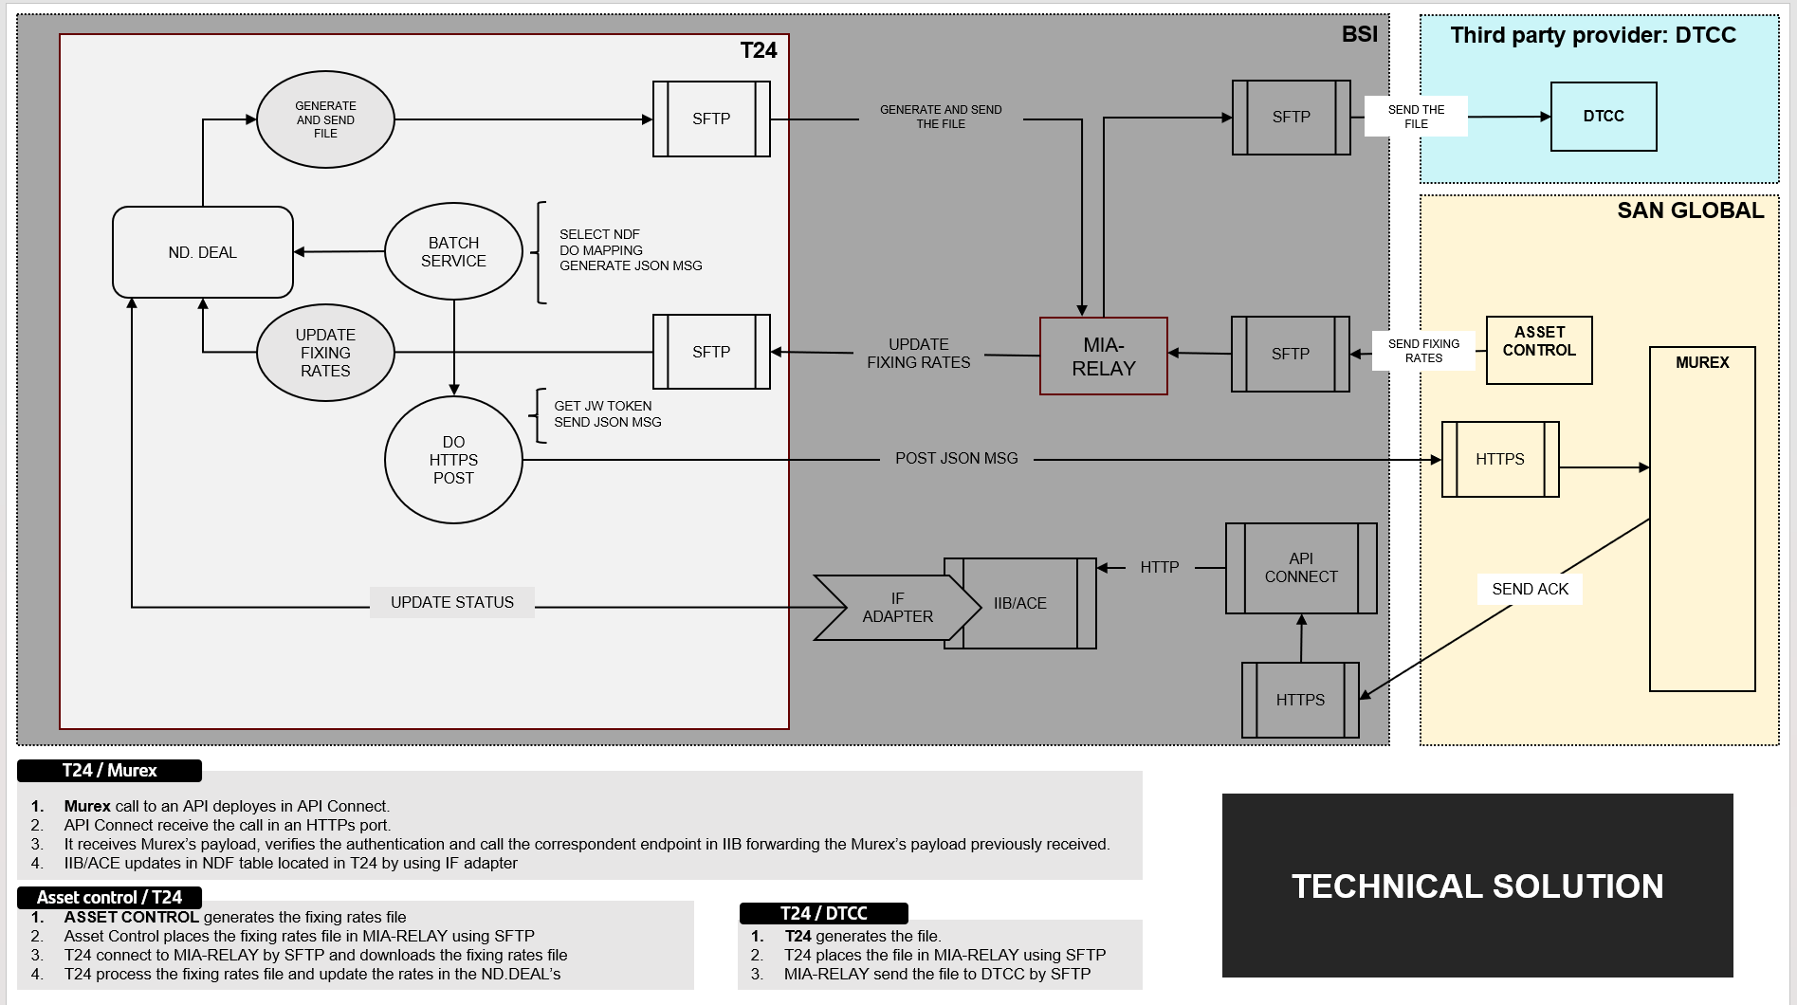

Requirements

Business Requirements
The table below presents the following information:
- BR #: Unique high level requirement identifier
- DR #: Unique detailed requirement identifier
- Requirement Description: Requirement text
- Scope ID: Related ID from the Scope Document
- Priority: Implementation priority for each requirement based on MoSCoW prioritization
- Phase: Project phase during which the requirement is expected to be implemented

BR # | Requirement Description | Scope ID | Priority | Phase
BR 1 | Main requirements on T24 NDF module set up | 1,2,3,4,5 | 1 | 1
BR 2 | Pre trade checks | 1,2,3,4,5 | 1 | 1 & 2
BR 3 | Post trade actions | 1,2,3,4,5 | 1 | 1
BR 4 | Confirmations | 1,2,3,4,5 | 1 | 1
BR 5 | Middle Office requirements | 1,2,3,4,5 | 1 | 1
BR 6 | Connect T24 to Murex and Global Systems through API  - JSON messages generation in T24.  - MX call back reception in T24  - Opening firewalls | 1,2,3,4,5 | 1 | 1
BR 7 | Data transmission enchantement T24 vs MEDEA | 1,2,3,4,5 | 1 | 1
BR 8 | 360: MEDEA Data processing and client statement/e-banking update | 1,2,3,4,5 | 1 | 1
BR 9 | Dood Frank – Reporting to DTCC. | 1,2,3,4,5 | 1 | 1
BR 10 | Reconciliations, Reports and other adjustments | 1,2,3,4,5 | 1 | 1

                - Please note that this BRD gather all requirements defined by all stakeholders however their satisfaction will depend on cost/benefit assessment that will be done by core team/ IT team resulting in its 1) implementation before Go-live, 2) satisfaction in post-implementation or 3) its no-implementation.

Further information for each requirement is described in document attached:

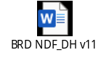
4. Non-Functional Requirements

Security

Req # | Requirement
4.1.1 | Project should comply with all security requirements defined by Infosec in the ISAR SAT-4161

Data Governance

Req # | Requirement
NA | NA

Auditability

Req # | Requirement
NF 4.3.1 | The system must generate an audit log for all NDF orders and trades.

End User Ease of Usability

Req # | Requirement
NA | NA

Performance Efficiency

Req # | Requirement
NA | NA

Scalability

Req # | Requirement
NA | NA

Reliability

Req # | Requirement
NA | NA

Business User Maintainability

Req # | Requirement
NA | NA

Backup and Recovery
Req # | Requirement
4.9.1 | Recovery Time Objective shall be 0 - 8 hours
4.9.2 | Recovery Point Objective shall 0 – 4 hours
4.9.3 | Recovery environment shall have sufficient capacity to support production workload

4.10 Availability

Req # | Requirement
4.10.1 | System should be available to access any time except for COB running.  System should be recovery between 0-4 hours.  Unavailability means, users cannot access to T24 to facilitate NDF trading to the client.

Table 1. Unavailability timeframes allowed for each Availability requirement
Availability of…  Means… | 99.95% | 99.90% | 99.50% | 98.00% | 95.00%
Daily downtime of | 43.2s | 1m 26.4s | 7m 12.0s | 28m 48.0s | 1h 12m 0.0s
Weekly downtime of | 5m 2.4s | 10m 4.8s | 50m 24.0s | 3h 21m 36.0s | 8h 24m 0.0s
Monthly downtime of | 21m 54.9s | 43m 49.7s | 3h 39m 8.7s | 14h 36m 34.9s | 1d 12h 31m 27.3s
Yearly downtime of | 4h 22m 58.5s | 8h 45m 57.0s | 1d 19h 49m 44.8s | 7d 7h 18m 59.0s | 18d 6h 17m 27.6s

